IoT, Wireless Communication, and RTOS:- Introduction to IoT, IoT Architecture, Protocols (MQTT, CoAP), IoT Security Principles and Common Threats Wireless Communication: Interfacing GSM(Call, SMS, Internet), Bluetooth Communication Basics, LoRa Communication Basics and Applications, Designing an IoT-Based Home Automation System, Introduction to RTOS Concepts, Free RTOS with STM32: Task Creation, Scheduling, and Management, RTOS Timers, Delays, and RTC Integration,Inter-task Communication: Queues and Semaphores
Trust Zone Technology: Introduction to ARM Trust Zone, Trust Zone Architecture and Features, Secure and Non-Secure Worlds: Configuration and Management, Implementing Trust Zone in STM32U575, Advanced Debugging and Optimization: Code and Memory Optimization Techniques, Debugging Strategies and Tools.

Introduction to IoT
IoT (Internet of Things) is a technology in which physical devices are connected to the Internet so that they can collect, exchange, and process data.
These devices can contain sensors, software, and communication systems that allow them to interact with other devices or systems.

Examples of IoT
- 🏠 Smart home: Smart bulbs, fans, and thermostats can be controlled through a phone.
- ⌚ Smart watch: Measures heart rate, steps, sleep, etc., and sends the data to an app.
- 🚗 Connected cars: Can collect information about the vehicle and communicate with other systems.
- 🌾 Smart agriculture: Sensors can monitor soil moisture and help control irrigation.

Main features of IoT
- Connectivity – Devices connect through the Internet or other networks.
- Sensing – Sensors collect information from the surroundings.
- Data processing – The collected data is processed to produce useful information.
- Automation – Devices can perform actions automatically based on the data.
- Communication – Devices can exchange information with other devices.

IoT Architecture
IoT architecture describes the different layers through which data moves from a physical device to an application.
A commonly taught IoT architecture has four layers:
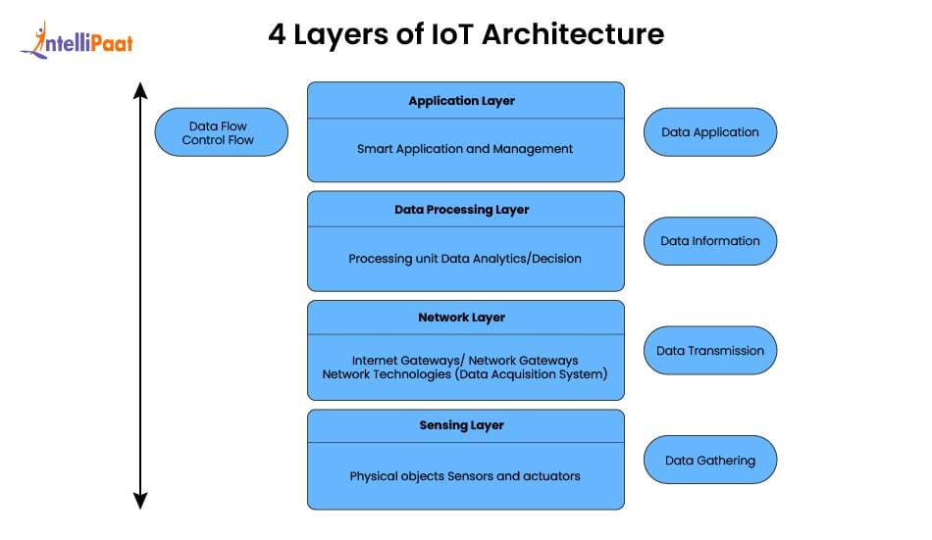

1. Perception Layer/Sensing Layer
- The lowest layer.
- Contains sensors and actuators.
- Sensors collect data from the physical environment.
- Actuators perform actions based on instructions.
Example: A temperature sensor measures room temperature.

2. Network Layer
- Transfers the collected data from devices to processing systems.
- Uses communication technologies such as Wi-Fi, Bluetooth, 4G/5G, Zigbee, etc.
Example: A smart thermometer sends its temperature reading through Wi-Fi.

3. Processing / Middleware Layer
- Receives and processes the collected data.
- May use cloud computing, databases, and data-processing systems.
- Converts raw data into useful information.
Example: A server analyses temperature readings and determines whether the room is too hot.

4. Application Layer
- Provides services to the end user.
- Shows the processed information or uses it to control devices.
Example: A mobile app displays the room temperature and allows the user to control the air conditioner.

Simple flow
Physical World → Sensors → Network → Data Processing → Application/User
Example:
🌡️ Temperature sensor → 📶 Wi-Fi → ☁️ Cloud/server → 📱 Mobile app

MQTT and CoAP Protocols
Protocols are rules that allow IoT devices to communicate and exchange data with each other.

1. MQTT — Message Queuing Telemetry Transport
MQTT is a lightweight messaging protocol designed mainly for IoT devices with limited resources and unreliable networks.
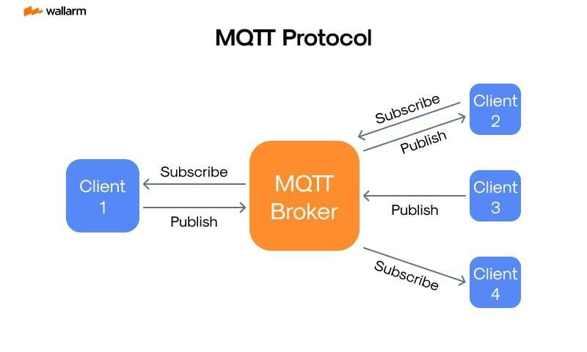
It uses a publish-subscribe model.
- Publisher: Sends data.
- Subscriber: Receives data.
- Broker: Acts as the middleman between publishers and subscribers.
- Topic: Identifies the type/category of data.
• Client: Any device (like a sensor or phone) that runs an MQTT library and connects to a broker to publish or receive data.
• Broker: The central server that receives messages from publishers and routes them to the correct subscribers
Example:
A temperature sensor publishes temperature data to the topic home/temperature. A mobile app subscribed to that topic receives the data.
Advantages:
- Lightweight and requires little bandwidth.
- Works well with unreliable networks.
- Supports communication between many devices.
- Suitable for devices with limited processing power.

2. CoAP — Constrained Application Protocol
CoAP is a lightweight web transfer protocol designed for resource-constrained IoT devices and networks.
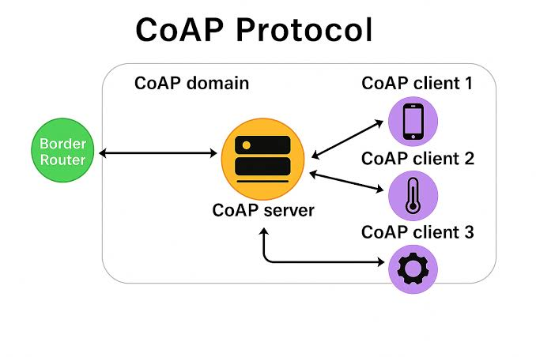
It follows a request-response model, similar to HTTP.
- Client: Sends a request.
- Server: Processes the request and sends a response.
- Uses methods such as GET, POST, PUT, and DELETE.
Example:
A smart-home app sends a GET request to a temperature sensor, and the sensor responds with the current temperature.
Advantages:
- Lightweight and efficient.
- Requires less bandwidth than HTTP.
- Designed for devices with limited memory and processing power.
- Supports low-power networks.

MQTT vs CoAP
MQTT | CoAP
Publish-subscribe model | Request-response model
Uses a broker | Usually direct client-server communication
Commonly uses TCP | Commonly uses UDP
Good for continuous data/messages | Good for accessing individual IoT resources
Example: sensor continuously publishes readings | Example: app requests the current reading
MQTT → Publish → Broker → Subscribe
CoAP → Request → Response

IoT Security Principles & Common Threats
IoT security refers to protecting IoT devices, networks, data, and services from unauthorized access, attacks, damage, and misuse.
IoT Security Principles

1. Confidentiality
Ensures that only authorized users can access data.
Example: Encrypting data sent by a smart health device.

2. Integrity
Ensures that data is not modified or corrupted without authorization.
Example: An attacker should not be able to change sensor readings.

3. Availability
Ensures that IoT devices and services are available when required.
Example: A smart security system should continue functioning during an attack.
These three are called the CIA Triad:
C–Confidentiality
I–Integrity
A – Availability

4. Authentication
Verifies the identity of a user or device.
Example: A smart lock verifies an authorized user's credentials.

5. Authorization
Determines what an authenticated user/device is allowed to do.
Example: A user may view a camera but may not change its settings.

6. Non-repudiation
Ensures that a party cannot deny an action or transaction that it performed.

7. Privacy
Protects the personal and sensitive information collected by IoT devices.
Common Threats

1. Unauthorized Access
Attackers gain access to devices or systems without permission.
Example: Using weak/default passwords to access a smart camera.

2. Malware
Malicious software infects IoT devices and may allow attackers to control them.

3. Denial of Service (DoS)
An attacker sends excessive requests to make a device or service unavailable.
DDoS uses multiple compromised devices to perform the attack.

4. Eavesdropping
An attacker secretly intercepts communication between IoT devices.

5. Man-in-the-Middle (MITM)
An attacker secretly places themselves between two communicating devices and may intercept or alter the communication.

6. Data Theft
Sensitive information collected by IoT devices is stolen.

7. Spoofing
An attacker pretends to be a legitimate device or user.

8. Physical Attacks
An attacker physically accesses an IoT device to extract data, modify it, or damage it.

9. Firmware Attacks
Attackers exploit vulnerabilities in the device's firmware or install malicious firmware.

10. Weak Passwords
Default or easily guessable passwords can allow unauthorized access.

Wireless Communication in IoT
Wireless communication allows IoT devices to communicate without physical cables.
Common wireless technologies include:
- Wi-Fi – high data rate, relatively higher power consumption
- Bluetooth/BLE – short range and low power
- Zigbee – low power, suitable for sensor networks
- GSM/Cellular – wide-area communication
- LoRa/LoRaWAN – long range and low power

GSM Interfacing
GSM = Global System for Mobile Communications

GSM Interfacing for Call
GSM (Global System for Mobile Communications) modules such as SIM800/SIM900 can be interfaced with a microcontroller to make and receive voice calls over a cellular network.

Block Diagram
Microcontroller
|
UART/Serial
|
GSM Module
(SIM800/SIM900)
|
SIM Card
|
GSM Cellular
Network
|
Mobile Phone

Components Required
- Microcontroller
- GSM module
- SIM card
- Antenna
- Power supply
- Mobile phone

Working
- Insert an active SIM card into the GSM module.
- The microcontroller communicates with the GSM module through UART/serial communication.
- AT commands are sent from the microcontroller to control the GSM module.
- The command ATD<number>; is used to initiate a voice call.
- The GSM network establishes the call with the destination number.
- The command ATH is used to terminate the call.

Important AT Commands
AT Command | Function
AT | Checks communication with GSM module
ATD<number>; | Makes a voice call
ATA | Answers an incoming call
ATH | Terminates the call

Applications
- Emergency alert systems
- Security systems
- Remote monitoring
- Industrial automation
- IoT alarm systems

GSM Interfacing for SMS
A GSM module can be interfaced with a microcontroller to send and receive SMS messages through the cellular network.

Block Diagram
Sensor
↓
Microcontroller
↓ UART
GSM Module
↓
SIM Card
↓
Cellular Network
↓
Mobile Phone

Working
- The microcontroller collects data from sensors or detects an event.
- It communicates with the GSM module through UART.
- The SMS mode is selected using the AT command AT+CMGF=1.
- The destination number is specified using AT+CMGS.
- The message is sent through the GSM cellular network.
- The receiving mobile phone receives the SMS.

Important AT Commands
AT Command | Function
AT | Checks GSM communication
AT+CMGF=1 | Selects SMS text mode
AT+CMGS | Sends SMS
AT+CMGR | Reads SMS
AT+CMGD | Deletes SMS

Example Sequence
AT
AT+CMGF=1
AT+CMGS="9876543210"
> Sensor Alert
> Ctrl+Z
The GSM module sends the specified message to the destination number.

Applications
- Security alerts
- Fire/gas detection
- Health monitoring
- Industrial fault notification
- Smart agriculture

GSM Interfacing for Internet
A GSM/GPRS module can provide Internet connectivity to a microcontroller or IoT device through a cellular network. It is useful when Wi-Fi is unavailable.

Block Diagram
Sensors
↓
Microcontroller
↓ UART
GSM/GPRS Module
↓
SIM Card
↓
Cellular Network
↓
Internet
↓
Cloud / IoT Server

Components Required
- Microcontroller
- GSM/GPRS module
- SIM card with data service
- Antenna
- Power supply
- Sensors/IoT devices

Working
- The SIM card is inserted into the GSM/GPRS module.
- The module registers with the cellular network.
- The microcontroller communicates with the module through UART.
- AT commands are used to configure the cellular data connection.
- The GSM/GPRS module establishes a data connection through the mobile network.
- Sensor data can then be transmitted to an Internet/cloud server.

Important AT Commands
Common commands include:
AT Command | Function
AT | Checks communication
AT+CPIN? | Checks SIM status
AT+CSQ | Checks signal strength
AT+CREG? | Checks network registration
AT+CGATT? | Checks packet-domain attachment
AT+CSTT | Configures APN
AT+CIICR | Establishes wireless data connection
AT+CIFSR | Obtains IP address
Exact commands vary depending on the GSM/GPRS module and firmware.

Applications
- Remote IoT monitoring
- Smart agriculture
- Vehicle tracking
- Remote industrial monitoring
- Environmental monitoring
- Cloud-based sensor systems

Advantages
- Internet connectivity over cellular networks
- Useful in remote locations
- Does not require local Wi-Fi
- Suitable for mobile and remote IoT devices

Bluetooth Communication Basics
Bluetooth is a short-range wireless communication technology used to exchange data between electronic devices without cables. It operates mainly in the 2.4 GHz ISM (Industrial, Scientific and Medical) band.

Main Features
- Short-range communication:
Typically used for communication over a few metres to tens of metres, depending on the Bluetooth class and version.
- Low power consumption:
Bluetooth Low Energy (BLE) is designed for very low-power IoT applications.
- 2.4 GHz frequency:
Bluetooth operates in the unlicensed 2.4 GHz ISM band.
- Wireless communication:
Devices communicate without physical cables.
- Data security:
Pairing, authentication and encryption help protect communication.

Basic Bluetooth Communication
Bluetooth Device A → 2.4 GHz Radio Link → Bluetooth Device B
For example:
Sensor → Bluetooth Module → Smartphone
The sensor collects data and sends it through a Bluetooth module. A nearby smartphone or other Bluetooth-enabled device receives and processes the data.

Bluetooth Network
Bluetooth devices can form a small network called a piconet. A piconet consists of a central device and one or more connected devices.
- Central: Manages the connection and communication.
- Peripheral: Connects to the central and provides or receives data.
In modern Bluetooth Low Energy (BLE), this central-peripheral model is commonly used.

Bluetooth Communication Process
- Discovery: Devices identify nearby Bluetooth devices.
- Pairing: Devices establish a trusted connection.
- Connection: A communication link is established.
- Data Transfer: Data is exchanged between the connected devices.
- Disconnection: The connection is terminated when communication is no longer required.

Bluetooth in IoT
Bluetooth, especially BLE, is widely used in IoT because of its low power consumption and support for short-range wireless communication.
Applications:
- Wearable devices
- Health-monitoring sensors
- Smart home devices
- Wireless keyboards and mice
- Beacons and asset tracking
- Mobile-to-device communication

Advantages
- Low power consumption
- Low cost
- Easy to use
- No cables required
- Suitable for short-range IoT communication
- BLE provides long battery life

Limitations
- Limited communication range
- Lower data rate than Wi-Fi
- Not suitable for long-distance communication
- 2.4 GHz interference can affect communication

LoRa

Definition
LoRa (Long Range) is a low-power, long-range wireless communication technology mainly used in IoT applications. It is designed for transmitting small amounts of data over long distances with low power consumption.

Main Features
- Long-range communication
- Low power consumption, suitable for battery-operated devices
- Low data rate
- Uses Chirp Spread Spectrum (CSS) modulation
- Suitable for large-scale IoT networks
- Good resistance to interference
- Suitable for devices that transmit data periodically
- Operates in sub-GHz ISM frequency bands, depending on the region

LoRa Communication
A typical LoRa-based IoT system consists of end devices, gateways, network server and application server.
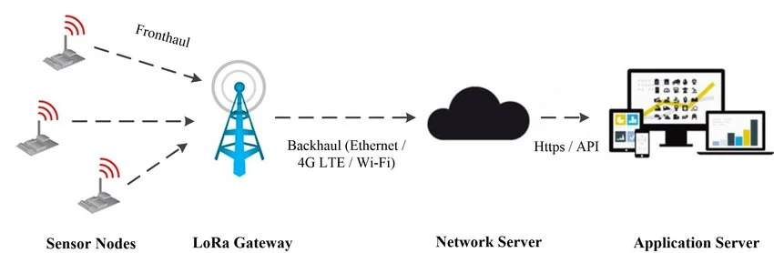
1. End Device[sensor nodes]:
Contains sensors and a LoRa communication module. It collects and transmits sensor data.
2. LoRa Gateway:
Receives LoRa radio signals from multiple end devices and forwards the data to the network server.
3. Network Server:
Manages the network, handles communication with gateways and processes device data.
4. Application Server:
Processes the data for a particular application and presents useful information to the user.

LoRa and LoRaWAN
- LoRa is the physical-layer radio technology used for long-range communication.
- LoRaWAN is a network protocol and architecture that operates over LoRa and manages communication between end devices, gateways and servers.

Advantages
- Long communication range
- Very low power consumption
- Long battery life
- Suitable for remote and battery-powered sensors
- Supports large-scale IoT deployments
- Low infrastructure and operating requirements

Limitations
- Low data rate
- Not suitable for video or other high-bandwidth applications
- Limited payload size
- Not suitable where very low latency or continuous high-speed communication is required

Applications of LoRa

1. Smart Agriculture
Sensors measure:
- Soil moisture
- Temperature
- Humidity
- Water level
The data can be sent over long distances to a central system.

2. Smart Cities
Used for:
- Smart street lighting
- Waste-bin monitoring
- Parking monitoring
- Environmental monitoring

3. Smart Metering
Used to remotely monitor:
- Electricity consumption
- Water consumption
- Gas consumption

4. Environmental Monitoring
Sensors can monitor:
- Air quality
- Temperature
- Humidity
- Flood/water levels

5. Industrial IoT
Used for:
- Machine monitoring
- Equipment condition monitoring
- Remote sensing

6. Asset Tracking
LoRa can be used to track the location/status of assets over large areas.

Here’s a KTU B.Tech 6-mark, exam-ready answer with the important points and a simple diagram.

Designing an IoT-Based Home Automation System
An IoT-based home automation system is a system in which household appliances such as lights, fans, ACs and security devices are monitored and controlled automatically through the Internet.

Basic Block Diagram
Sensors → IoT Controller → Internet/Wi-Fi → Cloud/Mobile App → User
User/Mobile App → Internet/Wi-Fi → IoT Controller → Relay/Actuator → Home Appliances

Main Components
- Sensors:
Sensors such as temperature, light, motion and gas sensors collect information from the home environment.
- IoT Controller:
A microcontroller such as ESP32, ESP8266 or Arduino processes sensor data and controls appliances.
- Communication Network:
Wi-Fi, Bluetooth, Zigbee or other wireless technologies are used to communicate between the controller, Internet and user device.
- Cloud/IoT Platform:
Sensor data can be stored and processed on a cloud server. It also allows remote monitoring and control.
- Actuators:
Relays, motors and smart switches are used to control appliances such as lights, fans and doors.
- User Interface:
A mobile application or web interface allows the user to monitor sensor values and control appliances remotely.

Working
- Sensors continuously collect information from the home.
- The IoT controller reads and processes the sensor data.
- The controller sends data to the cloud/mobile application through the Internet.
- The user can monitor the home and send control commands through the application.
- The controller receives the command and operates the required appliance through a relay or actuator.
- Automation rules can also be programmed, such as turning ON a light when motion is detected.

Applications
- Smart lighting and fan control
- Temperature and AC control
- Security and intrusion detection
- Gas/smoke monitoring
- Energy monitoring
- Remote appliance control

Advantages
- Remote monitoring and control
- Reduced energy consumption
- Improved convenience and safety
- Automatic operation of appliances
- Real-time monitoring
Yep — this is a 6-mark-type KTU question, and there are two parts. You should know the RTOS concepts plus the basic FreeRTOS task functions and scheduling.

Introduction to RTOS
RTOS (Real-Time Operating System) is an operating system designed to execute tasks within a specified time limit. It is commonly used in embedded and IoT systems where timely response is important.

Main RTOS Concepts
- Task:
A task is an independent unit of execution that performs a specific function.
- Scheduler:
The scheduler decides which task should run at a particular time.
- Task Priority:
Each task can be assigned a priority. Higher-priority tasks generally get CPU time before lower-priority tasks.
- Context Switching:
The CPU saves the state of one task and switches to another task.
- Task States:
A task can be in states such as Running, Ready, Blocked and Suspended.

Advantages of RTOS
- Fast and predictable response
- Efficient task management
- Supports multitasking
- Suitable for time-critical embedded applications
- Better resource management

FreeRTOS with STM32
FreeRTOS is a lightweight real-time operating system kernel commonly used with microcontrollers such as STM32.
It allows multiple tasks to run and manages CPU time using a scheduler.

Task Creation
A task can be created using:
xTaskCreate();
General form:
xTaskCreate(TaskFunction,
"TaskName",
StackSize,
Parameters,
Priority,
&TaskHandle);
The task function contains the operations performed by the task.
Example:
void Task1(void *argument)
{
while(1)
{
// Task operations
vTaskDelay(1000);
}
}

Important Task Management Functions
Function | Purpose
xTaskCreate() | Creates a task
vTaskDelete() | Deletes a task
vTaskSuspend() | Suspends a task
vTaskResume() | Resumes a suspended task
vTaskDelay() | Blocks the task for a specified time
vTaskPrioritySet() | Changes task priority

Scheduling in FreeRTOS
The FreeRTOS scheduler decides which ready task gets the CPU.
- Tasks are assigned different priorities.
- A higher-priority ready task can run before a lower-priority task.
- In preemptive scheduling, a running lower-priority task can be interrupted when a higher-priority task becomes ready.
- vTaskDelay() temporarily blocks a task, allowing other ready tasks to execute.

Example
Suppose there are three tasks:
- Task 1: Sensor reading – Priority 3
- Task 2: Display update – Priority 2
- Task 3: LED control – Priority 1
If all three are ready, the scheduler gives preference to Task 1 because it has the highest priority.

RTOS Timers, Delays, and RTC Integration
An RTOS (Real-Time Operating System) provides timing mechanisms that allow tasks to execute at specified times or intervals. Timers, delays and Real-Time Clocks (RTC) are commonly used in embedded and IoT systems.

1. RTOS Timers
An RTOS timer is a software mechanism used to perform an action after a specified time or at regular intervals.
Types of RTOS timers:
- One-shot timer: Executes its action only once after the specified time.
- Auto-reload timer: Repeatedly executes its action at fixed intervals.
Applications:
- Periodic sensor readings
- LED blinking
- Communication timeouts
- Periodic data transmission

2. Task Delays
A task delay temporarily blocks a task for a specified period. During this time, the processor can execute other ready tasks.
In FreeRTOS, the function:
vTaskDelay()
is commonly used to delay a task.
Example:
vTaskDelay(pdMS_TO_TICKS(1000));
This delays the task for approximately 1000 ms.
Advantages:
- Allows other tasks to execute
- Reduces unnecessary CPU usage
- Useful for periodic operations

3. RTC (Real-Time Clock)
An RTC is a hardware or dedicated clock module that maintains the actual date and time, even when the main processor is performing other operations.
It is used for:
- Date and time stamping
- Data logging
- Alarms
- Scheduled operations
- Time-based automation

4. RTC and RTOS Integration
The RTC can provide actual calendar time while the RTOS handles task scheduling and software timing.
Example:
RTC → Provides current date/time
RTOS → Schedules tasks
Task → Reads sensor → Adds timestamp → Stores/transmits data
For example, an IoT data logger can read temperature every 10 seconds using an RTOS timer and store the measurement with the current date and time obtained from the RTC.

Difference Between RTOS Timer and RTC
RTOS Timer | RTC
Software-based timing mechanism | Hardware/dedicated clock
Used for task timing | Maintains actual date and time
Used for periodic operations | Used for timestamps and schedules
Does not represent calendar time | Maintains calendar time

Inter-task Communication: Queues and Semaphores
Inter-task communication (ITC) is the mechanism used by tasks in an RTOS to exchange data and synchronize their activities. Queues and semaphores are two commonly used mechanisms in FreeRTOS.

1. Queues
A queue is a kernel-managed data structure used to transfer data between tasks. It normally follows the FIFO (First In, First Out) principle.
Basic operation:
Producer Task → Queue → Consumer Task
The producer places data into the queue, and the consumer retrieves the data.
Important FreeRTOS functions include:
- xQueueCreate() – creates a queue
- xQueueSend() – sends data to a queue
- xQueueReceive() – receives data from a queue
- vQueueDelete() – deletes a queue
Applications:
- Sending sensor data between tasks
- Communication between producer and consumer tasks
- Passing messages between tasks
- Buffering data

2. Semaphores
A semaphore is an RTOS synchronization mechanism used to coordinate tasks and control access to resources.
The two common types are:
Binary Semaphore:
Has two states: available and taken. It is commonly used for task synchronization or signalling.
Counting Semaphore:
Maintains a count and can be used when multiple instances of a resource are available.

Semaphore Operation
Task/Event → Semaphore → Waiting Task
For example, an interrupt can give a semaphore when data arrives. A waiting task receives the semaphore and starts processing the data.
Common FreeRTOS functions include:
- xSemaphoreCreateBinary() – creates a binary semaphore
- xSemaphoreTake() – takes/waits for a semaphore
- xSemaphoreGive() – gives/releases a semaphore

Queue vs Semaphore
Queue | Semaphore
Used mainly for data transfer | Used mainly for synchronization
Can store multiple data items | Usually represents a signal/resource
Generally follows FIFO | Indicates availability/event
Producer sends data | One task/event signals another

Example
Consider an IoT temperature monitoring system:
Sensor Task → Queue → Processing Task
The Sensor Task sends temperature readings through a queue. A semaphore can be used to signal the Processing Task whenever new sensor data is ready.
Here’s a KTU B.Tech 6-mark, exam-ready answer covering both the introduction and architecture/features.

Introduction to ARM TrustZone, Architecture and Features
ARM TrustZone is a hardware-based security technology developed by ARM to protect sensitive data and applications in embedded systems and IoT devices. It divides the processor and system resources into two isolated environments: Secure World and Normal World.

Basic Architecture
Application / OS
↓
Normal World ←→ Secure Monitor / Secure Gateway ←→ Secure World
↓ ↓
Normal Resources Secure Resources
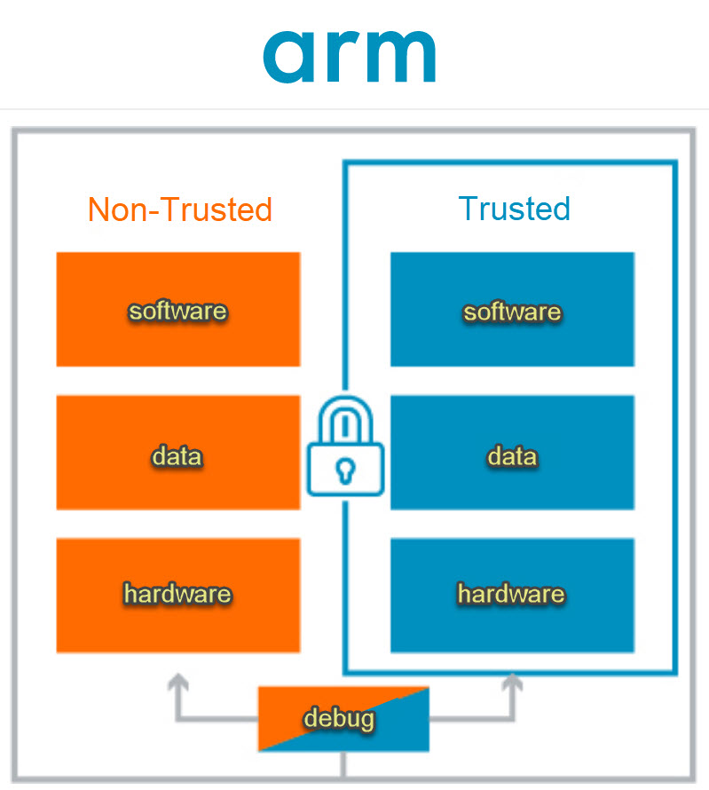

1. Secure World
The Secure World is used for security-sensitive operations and resources.
Examples:
- Encryption and decryption
- Secure key storage
- Authentication
- Secure boot
- Trusted applications
Only trusted software is allowed to access protected secure resources.

2. Normal World
The Normal World runs normal applications and operating systems such as Linux or Android.
It has access to non-sensitive resources but cannot directly access protected Secure World resources.

3. Secure Monitor / Gateway
A controlled mechanism is provided for communication between the Normal and Secure Worlds.
When the Normal World needs a protected service, it makes a controlled request to the Secure World. The Secure World performs the operation and returns the result.

Important Features of TrustZone
- Hardware-based isolation:
Secure and normal resources are separated using hardware-supported mechanisms.
- Secure and Normal Worlds:
Provides two execution environments with different security levels.
- Secure memory and peripherals:
Sensitive memory regions and peripherals can be protected from normal software.
- Secure boot:
Helps ensure that only trusted software is executed during system startup.
- Protection of cryptographic keys:
Sensitive keys and security credentials can be stored and processed in the Secure World.
- Controlled communication:
Secure services can be accessed from the Normal World only through controlled interfaces.

Applications
- IoT device security
- Secure payment systems
- Digital rights management
- Secure authentication
- Automotive systems
- Smart devices and embedded systems

Advantages
- Protects sensitive information
- Prevents normal applications from directly accessing secure resources
- Provides hardware-assisted security
- Helps protect cryptographic keys and trusted applications
- Suitable for resource-constrained embedded and IoT devices

Secure and Non-Secure Worlds: Configuration and Management
ARM TrustZone divides a processor system into two security domains: Secure World and Non-Secure World. This separation protects security-critical resources from normal applications.

1. Secure World
The Secure World contains trusted software and security-sensitive resources.
Examples:
- Secure boot
- Cryptographic operations
- Encryption keys
- Authentication
- Trusted applications
- Security-critical peripherals
Only authorized secure software can access these resources.

2. Non-Secure World
The Non-Secure World runs normal applications and operating systems.
Examples:
- User applications
- IoT application software
- Communication protocols
- Normal peripheral operations
Non-Secure software cannot directly access resources assigned to the Secure World.

3. Configuration of Security Domains
Memory, peripherals and other system resources are assigned as Secure or Non-Secure during system configuration.
The processor uses hardware security attributes to determine whether an access is permitted.
Example:
Secure Memory → Secure Software only
Non-Secure Memory → Normal Software
Secure Peripheral → Secure Software only
Non-Secure Peripheral → Normal Software

4. Communication Between Worlds
The Non-Secure World can request services from the Secure World through a controlled Secure Gateway.
Non-Secure Application → Secure Gateway → Secure Function → Result
This prevents direct and unauthorized access to secure resources.

5. Management
TrustZone security is managed by:
- Assigning memory regions as Secure/Non-Secure
- Assigning peripherals to the appropriate security domain
- Controlling access permissions
- Protecting secure functions
- Managing transitions between Secure and Non-Secure execution
- Preventing unauthorized Non-Secure access

Advantages
- Isolation of sensitive resources
- Protection against unauthorized access
- Secure execution of trusted applications
- Protection of cryptographic keys
- Improved security for IoT and embedded systems

Implementing TrustZone in STM32U575
The STM32U575 is an STM32 microcontroller based on the Arm Cortex-M33 processor and supports Arm TrustZone technology. TrustZone can be used to divide the microcontroller system into Secure and Non-Secure execution environments.

Basic Structure

STM32U575
→ Secure Application
→ Secure Memory / Secure Peripherals
↕ Secure Gateway
→ Non-Secure Application
→ Non-Secure Memory / Peripherals

Steps for Implementation
- Enable TrustZone
TrustZone is enabled in the microcontroller configuration so that the processor can operate with Secure and Non-Secure states.
- Configure Memory
Flash and SRAM regions are divided into Secure and Non-Secure areas.
  - Secure region → Security-critical code/data
  - Non-Secure region → Normal application code/data
- Configure Peripherals
Peripherals are assigned to the appropriate security domain. Sensitive peripherals can be kept Secure, while normal peripherals can be made Non-Secure.
- Configure Security Attribution
Security attribution mechanisms are used to determine whether memory and peripherals are accessible from the Secure or Non-Secure state.
- Create Secure and Non-Secure Applications
The Secure application handles security-critical operations, while the Non-Secure application performs normal application functions.
- Use Secure Gateway
Non-Secure software accesses selected Secure functions through controlled Secure Gateway (SG) entry points rather than directly accessing Secure resources.

Example
Consider an STM32U575 IoT device storing an encryption key:
Non-Secure Application
↓
Secure Gateway
↓
Secure Function
↓
Encryption Key in Secure Memory
The encryption key remains inside the Secure environment, while the Non-Secure application can request encryption through an authorized Secure function.

Tools Used
TrustZone development for STM32U575 can be configured using STM32CubeMX/STM32CubeIDE and the STM32 security configuration tools.

Benefits
- Protection of sensitive data and keys
- Isolation of security-critical code
- Secure execution of trusted functions
- Protection against unauthorized peripheral and memory access
- Suitable for secure IoT and embedded applications
Write a program to implement trust zone in STM32U575

Objective
To demonstrate communication between the Secure World and Non-Secure World using a Secure Gateway function.

1. Secure World Program
The secure application contains a function that can be called by the Non-Secure application.
#include "main.h"

void Secure_LED_On(void)
{
HAL_GPIO_WritePin(GPIOA, GPIO_PIN_5, GPIO_PIN_SET);
}
The function can be exposed as a Non-Secure Callable (NSC) function using the TrustZone configuration.

2. Non-Secure World Program
The Non-Secure application calls the secure function through the Secure Gateway.
#include "main.h"

/* Secure function */
extern void Secure_LED_On(void);

int main(void)
{
HAL_Init();

/* System and GPIO initialization */
SystemClock_Config();
MX_GPIO_Init();

while (1)
{
/* Call Secure World function */
Secure_LED_On();

HAL_Delay(1000);
}
}

Working
- The STM32U575 starts execution in the Secure World.
- Secure memory and peripherals are configured.
- The secure function Secure_LED_On() is made available through a Secure Gateway.
- The Non-Secure application calls the secure function.
- The Secure World executes the function.
- HAL_GPIO_WritePin() turns ON the LED.
- HAL_Delay() creates a 1-second delay.

Block Diagram
NON-SECURE WORLD
|
| Secure Function Call
↓
Secure Gateway (SG)
|
↓
SECURE WORLD
|
↓
HAL_GPIO_WritePin()
|
↓
LED

Important Points
- STM32U575 uses an Arm Cortex-M33 processor.
- TrustZone provides Secure and Non-Secure execution states.
- HAL functions such as HAL_GPIO_WritePin() can be used in the application.
- Secure functions must be exposed through an appropriate Non-Secure Callable (NSC) interface.
- Memory and peripheral security attributes are configured using STM32 security configuration tools/CubeMX.
- The Non-Secure application should not directly access resources assigned to the Secure World.

Code and Memory Optimization Techniques
Optimization is the process of improving an embedded program so that it uses less memory and CPU time while maintaining the required functionality.

1. Code Optimization Techniques

1. Reduce unnecessary code
Remove unused functions, variables, libraries and duplicate code to reduce program size.

2. Optimize loops
Avoid unnecessary calculations inside frequently executed loops. Move constant calculations outside the loop whenever possible.

3. Use suitable data types
Use the smallest suitable data type for variables.
Example:
uint8_t count;
can be used instead of a larger integer type when the value is within its range.

4. Avoid unnecessary function calls
Frequently called small functions can be optimized using appropriate compiler optimization techniques such as inlining.

5. Use compiler optimization
Compilers such as GCC provide optimization levels such as:
-O0 → No optimization
-O1 → Basic optimization
-O2 → Higher optimization
-O3 → Aggressive optimization
-Os → Optimize for size
For embedded systems, -Os can be useful when program memory is limited.

2. Memory Optimization Techniques

1. Reduce RAM usage
Avoid unnecessarily large arrays and variables.

2. Use constant data efficiently
Constant data can be placed in program/Flash memory instead of consuming RAM where appropriate.

3. Optimize data structures
Arrange structures and select data types carefully to reduce unnecessary memory usage.

4. Avoid memory fragmentation
In embedded systems, excessive dynamic memory allocation using malloc() and free() can cause fragmentation. Static allocation or memory pools can be preferred for predictable systems.

5. Optimize stack usage
Avoid unnecessarily large local arrays and excessive recursion to prevent stack overflow.

3. Benefits
- Reduced Flash and RAM usage
- Faster execution
- Lower power consumption
- Better system responsiveness
- More efficient use of microcontroller resources

Debugging Strategies and Tools
Debugging is the process of finding, identifying and correcting errors or faults in an embedded system.

1. Debugging Strategies

1. Identify the problem
First determine the symptoms and conditions under which the fault occurs.

2. Reproduce the error
Run the program repeatedly under the same conditions to identify when and how the error occurs.

3. Use breakpoints
A breakpoint temporarily stops program execution at a selected line so that variables and processor state can be examined.

4. Step-by-step execution
Execute the program one instruction or line at a time to find where the incorrect behaviour begins.

5. Check variables and registers
Monitor variable values, CPU registers, memory contents and peripheral registers during execution.

6. Use logging and trace information
UART/serial messages, logs and trace data can help identify program flow and runtime errors.

2. Common Debugging Tools

1. Debugger
An IDE debugger allows the programmer to:
- Set breakpoints
- Step through code
- Inspect variables
- Examine registers
- Watch memory

2. ST-LINK
ST-LINK is commonly used with STM32 microcontrollers for programming and debugging through interfaces such as SWD.

3. STM32CubeIDE
STM32CubeIDE provides code development, compilation and debugging facilities for STM32 devices.

4. Serial/UART Debugging
Debug messages can be sent through UART and viewed on a computer using a serial terminal.

5. Logic Analyzer
A logic analyzer is useful for examining digital communication signals such as UART, SPI and I²C.

6. Oscilloscope
An oscilloscope can be used to observe electrical signals, timing, frequency and signal integrity.

3. Typical Debugging Process
Detect Fault
↓
Reproduce Fault
↓
Set Breakpoints / Add Logs
↓
Examine Variables & Registers
↓
Identify Root Cause
↓
Modify Code
↓
Test Again

4. Common Embedded-System Errors
- Incorrect pointer or memory access
- Stack overflow
- Incorrect peripheral configuration
- Timing errors
- Interrupt-related problems
- Communication errors
- Incorrect variable values

